EXPERIMENT-1
GOOD DESIGN AND BAD DESIGN
VISHNU PRIYAN M
240701604

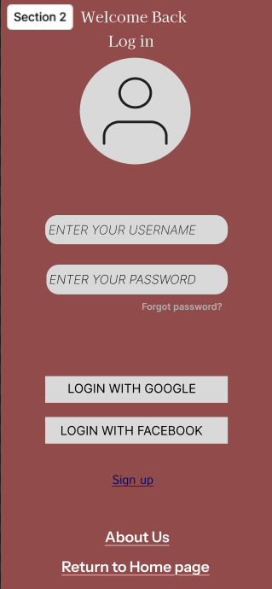
Old Login UI Design
Features & Drawbacks Identified:
• Flat & Dull Interface:
o The background uses a single dark brown shade.
o Lacks modern design elements like gradients, shadows, or visual depth.
o The UI feels outdated and visually unappealing.
• Poor Visual Hierarchy:
o “Welcome Back” and “Log in” do not stand out clearly from other text.
o No strong distinction between primary and secondary elements.
o Important actions are not emphasized properly.
• Weak Typography & Readability:
o Font styles are inconsistent across sections.
o “Forgot password?” text is too small and easily overlooked.
o Spacing between elements is uneven.
• Basic Profile Icon Design:
o The profile icon is overly simple and lacks refinement.
o No border, shadow, or stylistic enhancement to give a modern feel.
• Unattractive Button Styling:
o Social login buttons look plain and rectangular.
o No hover effect or visual feedback indication.
o Buttons do not strongly attract user attention.
• Low Visual Engagement:
o No background imagery or decorative elements.
o The interface lacks personality and branding presence.
• Layout Imbalance:
o Large empty spaces reduce visual compactness.
o Bottom links like “About Us” and “Return to Home page” feel disconnected from the main login section.

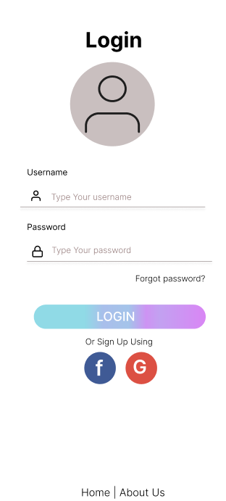
Modified Login UI Design
Features & Enhancements:
• Modern & Clean Interface:
o A white background improves clarity and professionalism.
o The design looks minimal and contemporary.
• Improved Visual Hierarchy:
o “Login” heading is bold and clearly emphasized.
o Proper distinction between labels, input fields, and action buttons.
o Logical top-to-bottom user flow is maintained.
• Enhanced Typography & Spacing:
o Consistent font sizing improves readability.
o Proper spacing between elements creates visual balance.
o Labels are clearly separated from placeholders.
• Icon Integration in Input Fields:
o Username and password icons enhance usability.
o Icons provide quick visual cues for users.
• Gradient Call-to-Action Button:
o The LOGIN button uses gradient styling, making it visually attractive.
o Clearly stands out as the primary action element.
• Better Social Login Representation:
o Facebook and Google icons are visually distinct.
o Circular icon design makes them modern and appealing.
• Improved Alignment & Structure:
o All elements are centrally aligned.
o Balanced margins improve overall layout consistency.
• Professional Aesthetic Appeal:
o Clean color palette improves user trust.
o Interface feels more application-ready and user-friendly.

